**Lampiran *Output* Aplikasi**

1. **Tampilan Login**

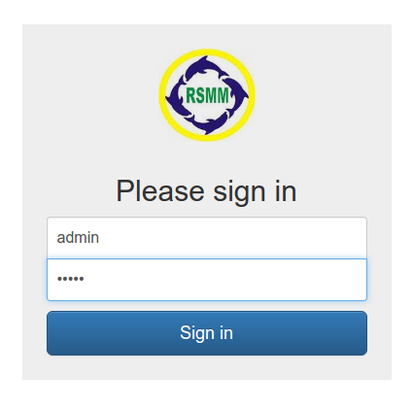

1. **Tampilan List Permission**

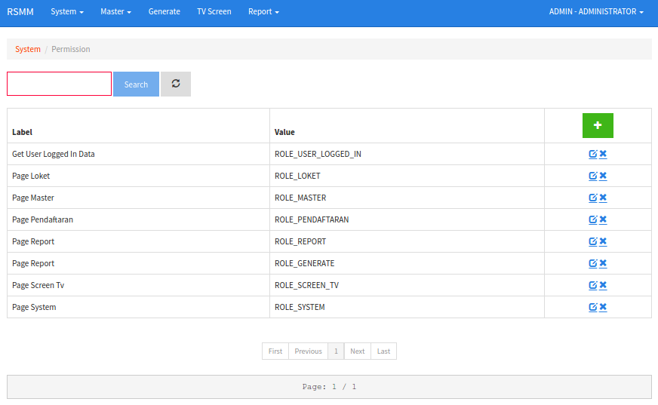

1. **Tampilan Input Permission**

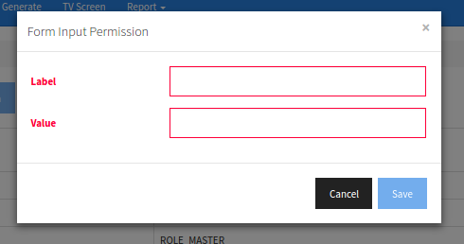

1. **Tampilan List Role**

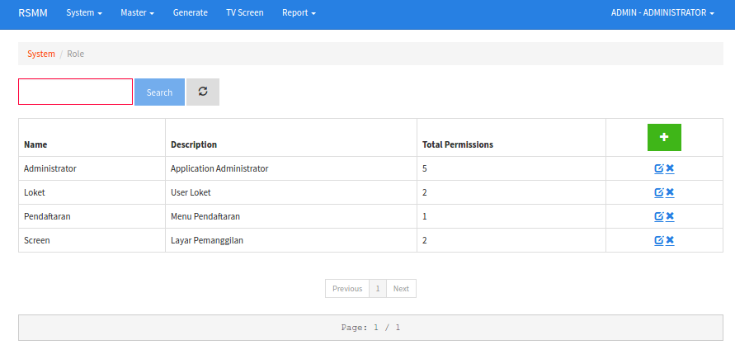

1. **Tampilan Input Role**

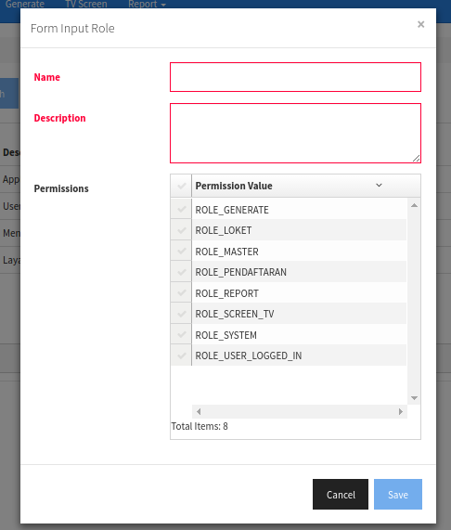

1. **Tampilan List User**

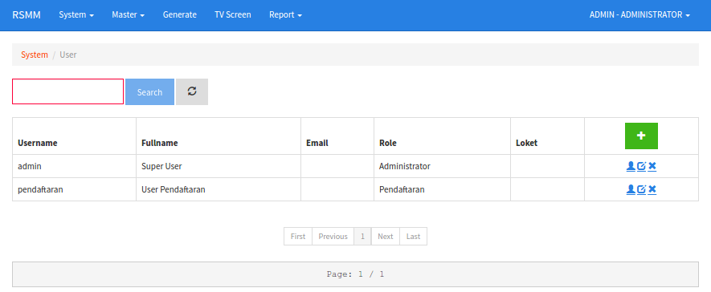

1. **Tampilan Input User**

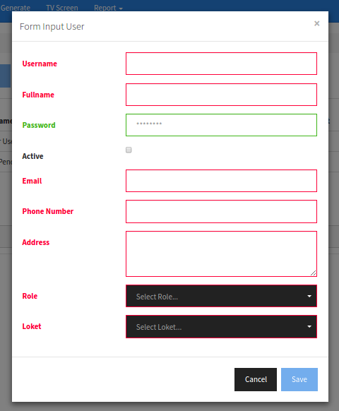

1. **Tampilan List Category**

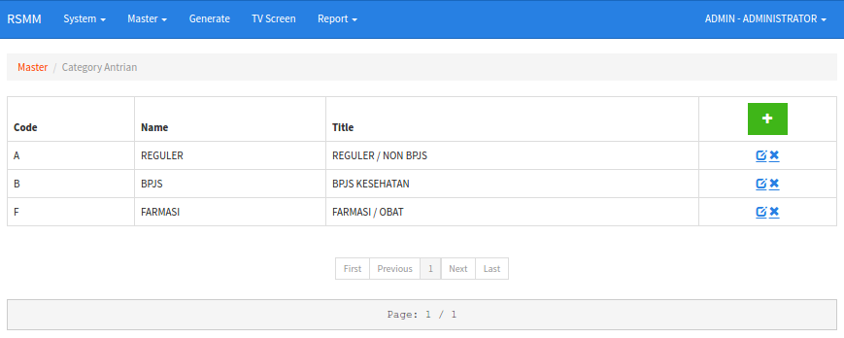

1. **Tampilan Input Category**

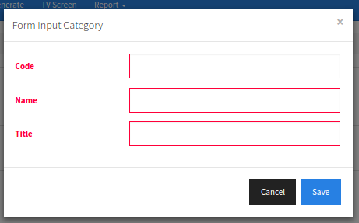

1. **Tampilan List Poli**

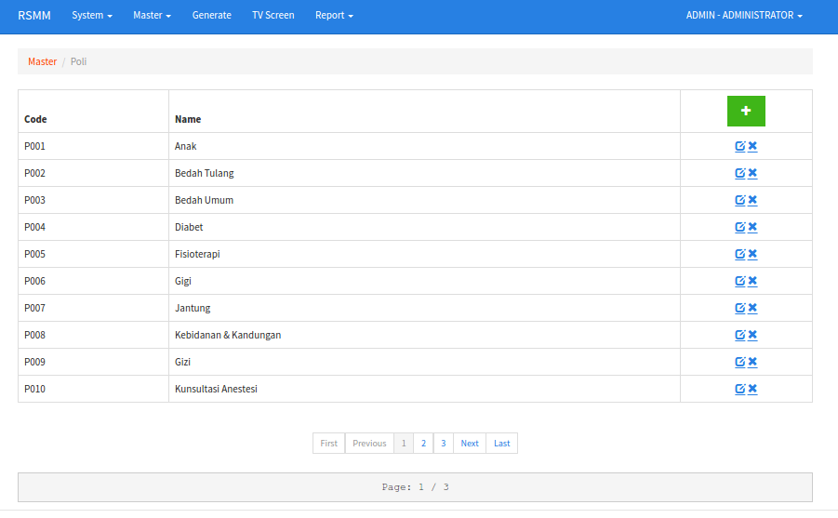

1. **Tampilan Input Poli**

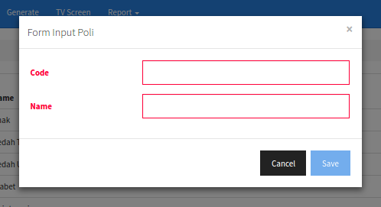

1. **Tampilan List Loket**

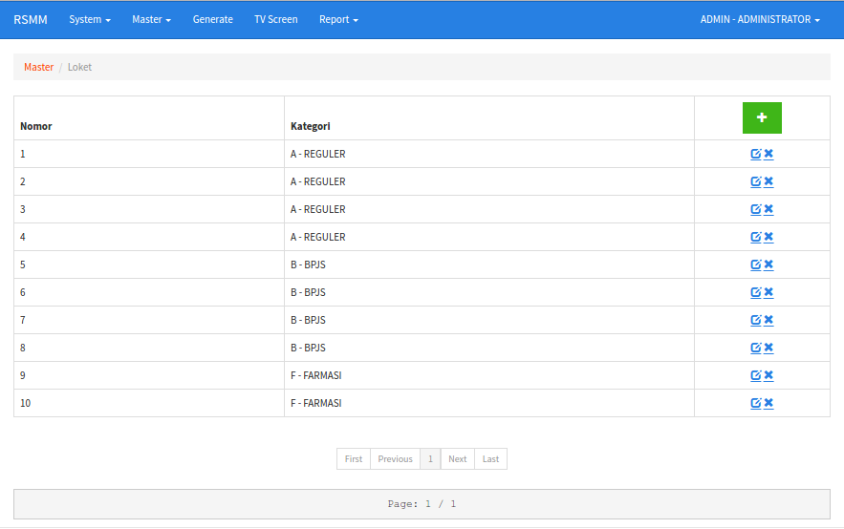

1. **Tampilan Input Loket**

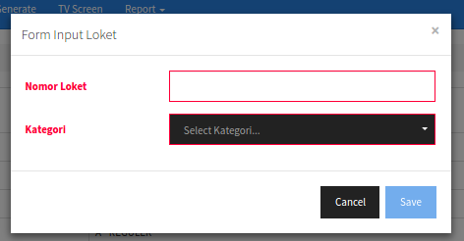

1. **Tampilan List Dokter**

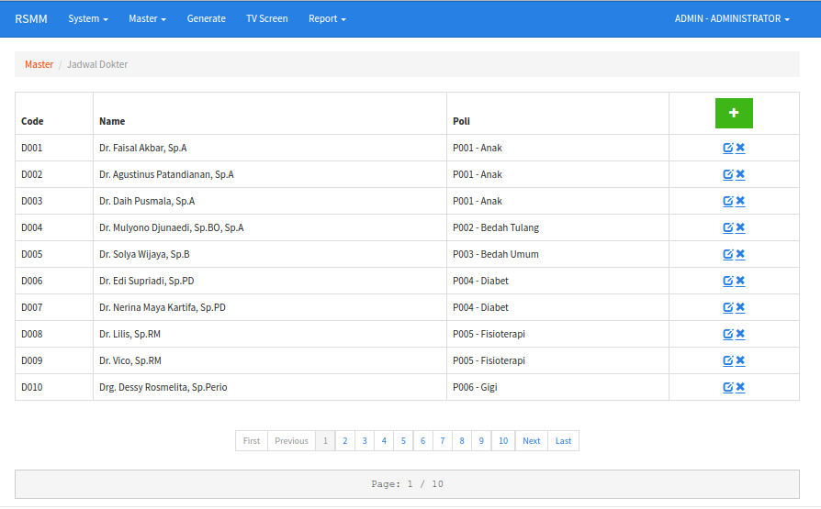

1. **Tampilan Input Dokter**

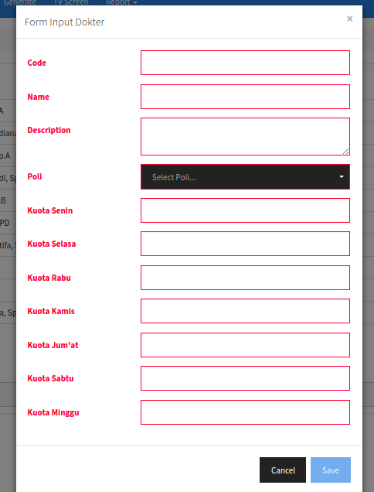

1. **Tampilan BOD**

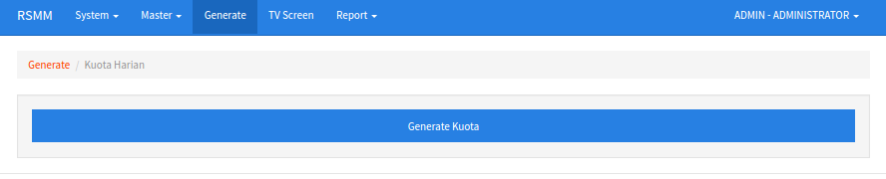

1. **Tampilan Pendaftaran Antrian**

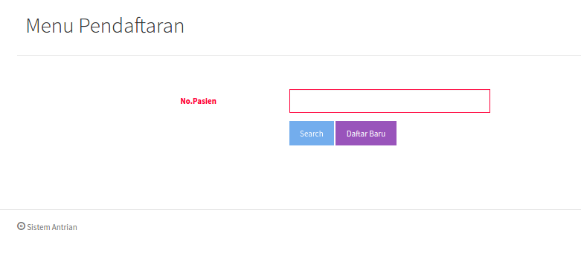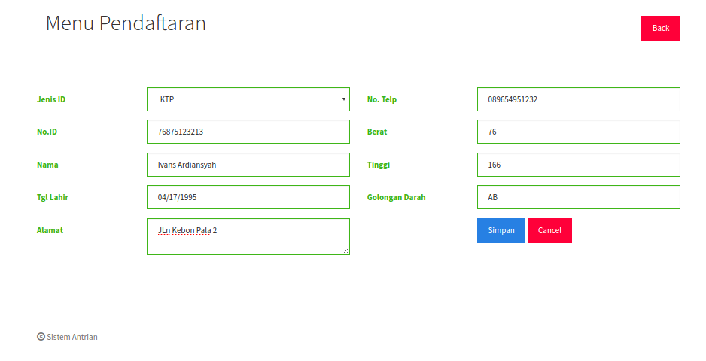

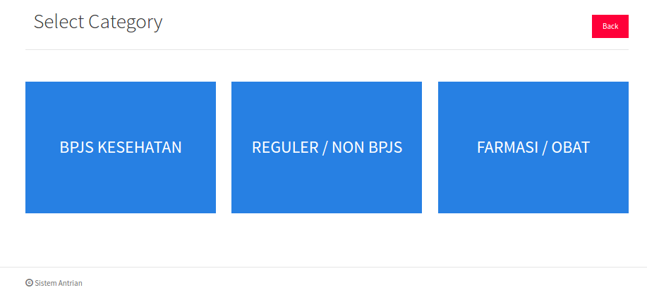

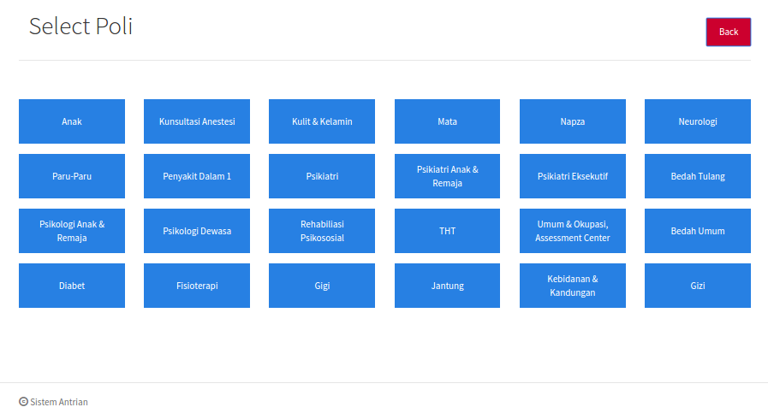

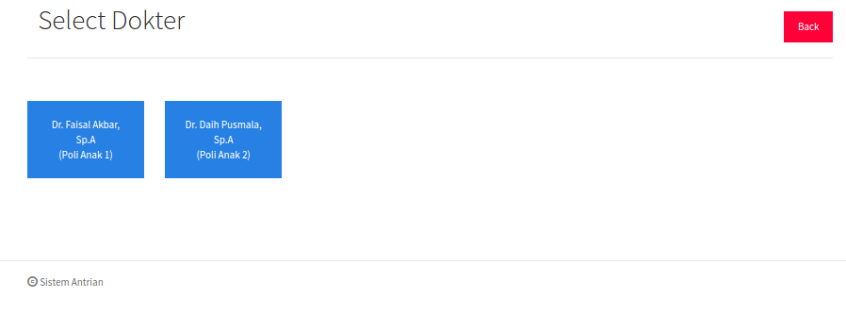

1. **Tampilan Print Tiket**

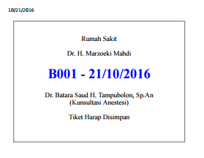

1. **Tampilan Form Loket**

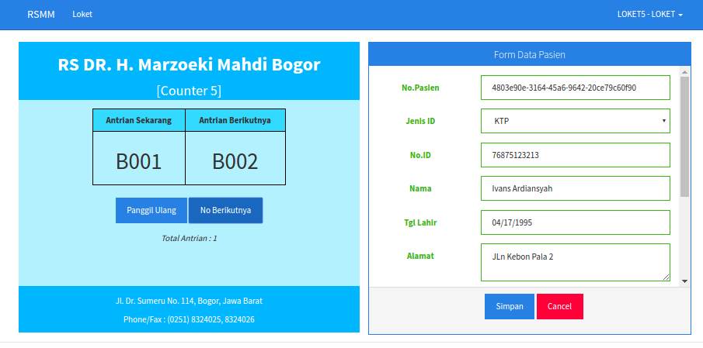

1. **Tampilan Screen Information**

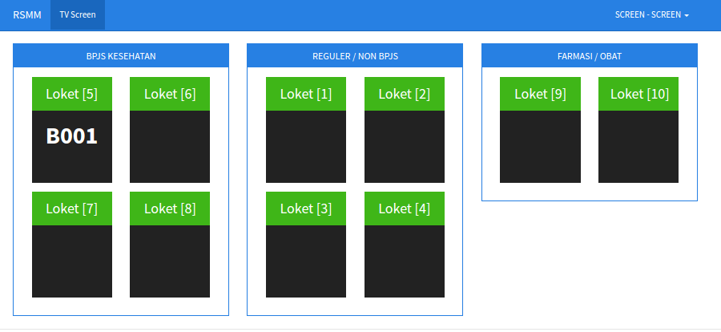

1. **Tampilan Report Antrian**

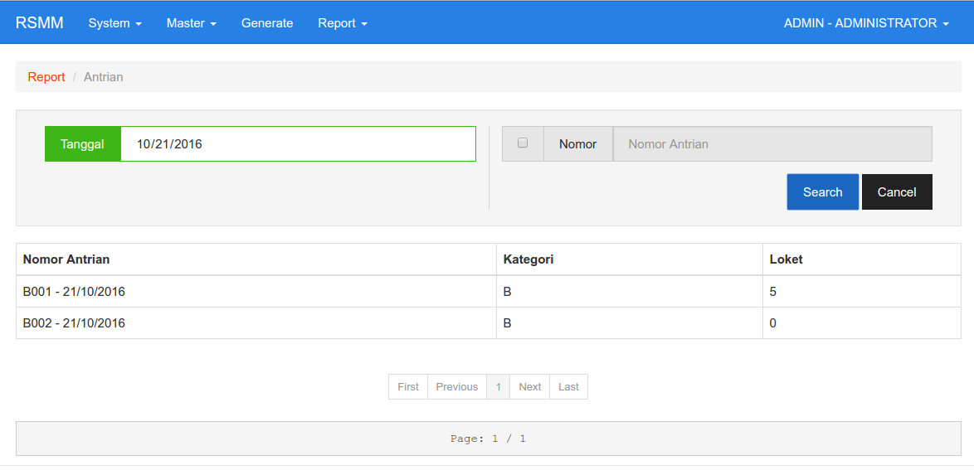

1. **Tampilan Report Kuota**

